
ATAR Biology

Unit 1: Topic 2
Week 5 – Ecosystems

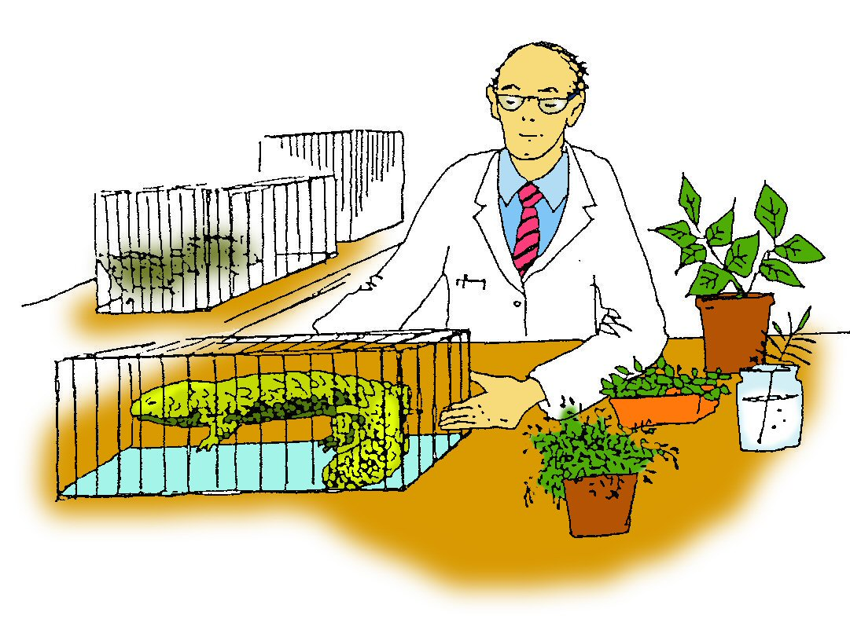

Student Study Notes

Unit Content
- Ecosystems are diverse, composed of varied habitats, consisting of a range of biotic and abiotic factors, and can be described in terms of their component species, species interactions and the abiotic factors that make up the environment.
- In addition to biotic factors, abiotic factors, including climate and substrate, can be used to describe and classify environments.

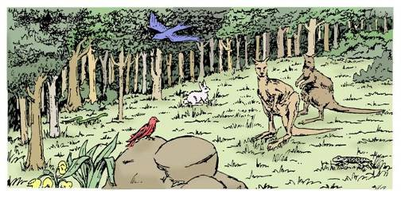
In this section you will investigate the living and non-living components of ecosystems.
Australia has a diversity of natural ecosystems ranging from eucalypt forests to wetlands, grasslands, deserts and coastal regions.

All ecosystems have the same basic requirements but each one exists through the many special roles and interactive relationships between the living members which make up a community.

The activities in this section should assist you in completing the assessment task and develop your understanding of communities as groups of different species living together in a particular area.

Biological Complexity
Ecology is the study of the relationships between organisms and their physical and biotic environment. Living organisms can be studied at different levels of complexity.

Biosphere
Biome
Ecosystem
Community
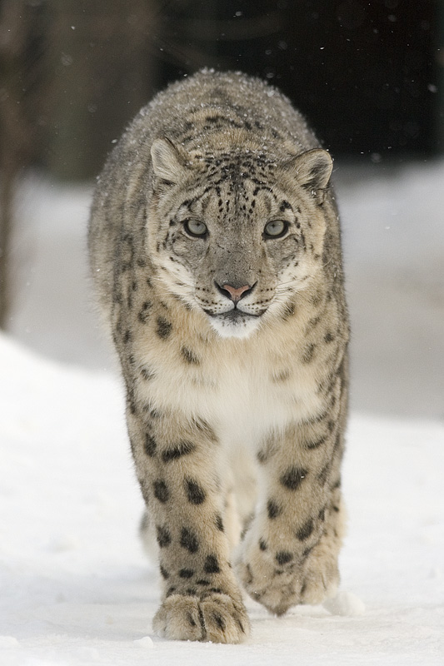
Population
Individual

Snow leopard by Bernard Landgraf available at https://commons.wikimedia.org/wiki/File:Uncia_uncia.jpg CC BY-SA 3.0

Biomes
A biome is defined as a large-scale community of organisms shaped by common environmental conditions, such as patterns of climate and geology. The biosphere encompasses all living things on Earth and comprise a number of terrestrial and aquatic biomes. Biomes within the same category have specific, characteristic features.
Tropical rainforests, deserts and tundras are examples of terrestrial biomes. They roughly correspond to particular variations in vegetation types, climates, topography and soil type. So for example grasslands in both Australia and Africa are characterized by very few trees, a dry season that can be very hot or cool and a wet season that is warm. Lakes, oceans and rocky shores are examples of aquatic biomes and these form the largest section of the biosphere.
Factors that influence where biomes are located include:
- Temperature
- Rainfall
- Water currents
- Air currents and wind
- Human activity

Ecosystems
An ecosystem is a system which includes all of the living and non-living factors in a certain area. An ecosystem is formed by biotic (living) factors interacting with one another and the abiotic (non-living) surroundings.
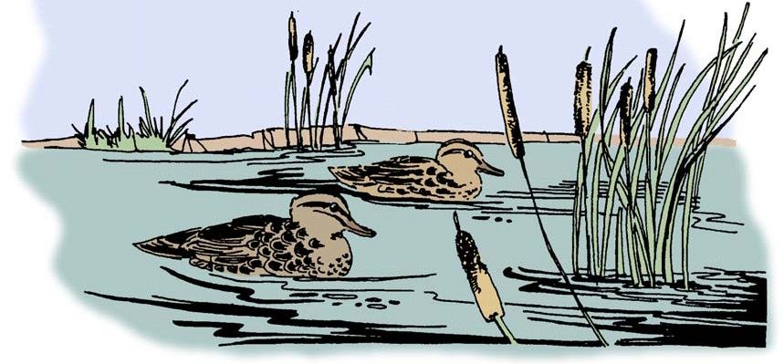

Biotic components of an ecosystem
These include:

- producers – usually green plants that make their own food through photosynthesis
- consumers – usually animals which feed on plants or other animals
- decomposers – which live on, and decompose, dead organic matter.

Abiotic components of an ecosystem
These include:

- physical factors such as temperature, light, humidity, winds and ocean currents
- inorganic matter such as carbon, nitrogen, oxygen and water
- energy in the form of heat and light from the sun.

Classifying Ecosystems
Australia has a wide diversity of ecosystems ranging from eucalypt forests to wetlands, grasslands, deserts, coastal rock pools and dunes. Ecosystems are often classified by dominant biotic features such as dominant type of plant e.g. Jarrah forest.

When naming the ecosystems shown in the photos you can see that it is usual to use two names. For example, the ecosystem shown in below has been named a Jarrah Forest.
- Jarrah is the name of the dominant plant species.
- Forest is a descriptive name used to describe the percentage of canopy cover.
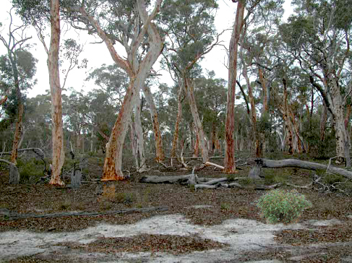
Reproduced with permission from Leonie Wilson
Abiotic factors, such as climate and substrate can also describe and classify environments. The climate and the soils of a particular area influence the vegetation that grows there.

Climate
Climatic factors include temperature, water, light and wind. Broad differences in vegetation are influenced by climate. Climatic conditions across the Earth's surface vary in a predictable manner. High latitudes are cooler, the tropics warmer. The geographic distribution of vegetation types and soil types conform approximately with the observed global climatic patterns.

World Biomes © Brynn Schaffner 2010
http://www.blueplanetbiomes.org/world_biomes.htm
Substrates

Substrates or base material, such as soil texture, or the concentration of salt in a body of water can be used to classify an environment. Soils develop in response to climate and particularly rainfall levels. Because of this, vegetation and soils have associations with areas having particular climates. There is a variety of soil types.

Soil types:
Sandy soil
• coarse and gritty and particles do not hold together well
• described as a light soil because it is easy to dig but does not retain water.

Clay soil
• holds water/poor drainage/poor o2
• particles stick together well
• described as a heavy soil because it is difficult to dig.

Loam
• contains similar proportions each of sand, silt and clay
• holds water/good drainage

Each of these soil types may contain varying proportions of organic material. Some soils are almost entirely organic material e.g. peat. The soil type often influences the vegetation found there. For example, many native West Australian plants that normally grow in sandy soils, cannot grow in the rich, loamy soils of the Eastern states.

PRACTICE QUESTIONS:

A desert climate is generally dry with little or no rainfall and a wide range of temperatures between night and day. The harsh conditions of desert regions result in low biodiversity.
A rainforest typically has a constant temperature with high rainfall and humidity.

1. Use your textbook and additional resources to complete the comparison table below.

Climatic factor | Desert | Rainforest
Temperature range
Water humidity
Water annual rainfall
Light intensity
Wind factor strong/light

Climate refers to the meteorological conditions, including temperature, precipitation, and wind, that characteristically prevail in a particular region.

2. The temperature (ºC) and precipitation (rainfall n mm) for three different terrestrial ecosystems have been recorded over a twelve-month period.

- Construct a graph for each ecosystem with the data provided. For each ecosystem plot the temperature as a column graph and precipitation as a line graph on the same graph.

Ecosystem A
Month | J | F | M | A | M | J | J | A | S | O | N | D
Temp °C | 31.7 | 30.4 | 30.2 | 29.6 | 27.8 | 25.8 | 26.2 | 27.2 | 28.4 | 30.4 | 31.1 | 31.1
Precip (mm) | 447.2 | 468.7 | 441.5 | 246.5 | 103.0 | 54.8 | 40.4 | 38.7 | 40.1 | 74.4 | 119.3 | 188.1

Title: ___________________________________________
Precipitation (mm)
Temperature (°C)
Months of the Year
40
0
160
120
80

Ecosystem B

Month | J | F | M | A | M | J | J | A | S | O | N | D
Temp °C | 31.1 | 31.7 | 29.7 | 25.9 | 22.4 | 19.3 | 18.4 | 19.0 | 20.2 | 23.2 | 29.1 | 24.7
Precip (mm) | 9.6 | 14.2 | 14.6 | 40.6 | 99.8 | 159.1 | 156.5 | 117.8 | 73.6 | 44.1 | 26.6 | 11.3

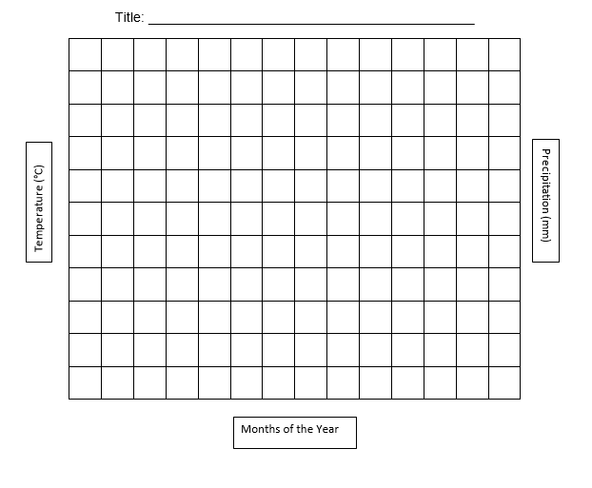

Ecosystem C

Month | J | F | M | A | M | J | J | A | S | O | N | D
Temp °C | 18.0 | 16.5 | 13.3 | 10.7 | 5.4 | 3.2 | 2.5 | 2.0 | 5.8 | 10.5 | 13.2 | 15.1
Precip (mm) | 74.4 | 56.2 | 131.6 | 53.8 | 79.0 | 155.2 | 147.4 | 142.6 | 259.4 | 162.6 | 120.4 | 128.2

- Use your completed graphs to answer the following questions.
Which ecosystem (A, B or C)
  - lies closest to the equator? …………………………………… ____
  - lies furthest from the equator? ……………………………….. ____
  - has seasonal changes in temperature? …….……………... ____
  - has the longest growing season? …………………………..… ____
  - has the highest total annual precipitation? ……..…………… ____
  - has a measurable snowfall? …………………………………… ____
  - has the highest humidity? ……..…...………………….. …. ____
  - has the driest soil? ……..………..…………………………..…. ____
  - has the highest soil moisture content?........... .... …………… ____
  - has the fastest rate of decomposition of organic material?..... ____
  - has the greatest abundance of plant growth?......... …………. ____
  - has animals that enter a seasonal period of hibernation?…… ____
  - has plants that encounter a water shortage at some time of the year? ____
  - has animals that encounter a water shortage at some time of the year? ____
- Based on your answers to part ii, name the type of ecosystem for each location.
A _________________________
B _________________________
C __________________________
- Which ecosystem (A, B or C) would you expect to have the greatest variety of plant and animal life? Give reasons for your answer.

3. An ecosystem can be best defined as:
- All the organisms present in a given habitat.
- A large area of land containing organisms that share similar abiotic requirements.
- A major climatic region with specific vegetation types.
- The interactions between biotic and abiotic factors in a particular area.

4. Ocean environments are classified according to depth. As ocean depth increases:
- Temperature decreases and pressure increases.
- Temperature increases and pressure increases.
- Amount of light decreases and temperature increases.
- Amount of light increases and temperature decreases.

5. A biome is:
- The sum of all ecosystems across the world.
- The region within which all living things are found on Earth.
- A system which includes all of the living and non-living factors in a certain area.
- A large scale community of organisms

6. Explain how water currents can influence where biomes are located.

7. Contrast biotic and abiotic factors and provide an example of each.

8. What is a microclimate? Provide an example how a microclimate may be created within an ecosystem.

